1. **Appendix**
   1. ***Health Club Lesson Plans***
      1. ***Lesson 1: Introduction***

 Preparations:

* Write health topics to be covered on board
  + Introduction
  + Personal Hygiene
  + Water and Airborne Diseases
  + Global Handwashing Day
  + Oral Hygiene
  + Resisting Peer Pressure
  + Drugs & Alcohol
  + Jeopardy Review Game
* Bring big paper and markers for ground rules
* Bring photo album
* Bring ? Box
* Bring ? Slips
* Bring name tag cards
  1. Name tags
  2. Introduction to me
     1. Show photo album
     2. Write American stereotypes on the board
  3. Introduction to health
     1. Go over list of topics to be covered
        1. Is there anything missing they would like to learn?
  4. Set ground rules
     1. Write rules on paper asking class for suggestions
  5. Teach Back
  6. Introduce ? Box
     1. Have students pass in questions before leaving the class
     2. ***Lesson 2: Personal Hygiene***

 Preparations:

* Write objectives on the board
* Write myth on the board
* Make power point to answer ?'s
* Download video ahead of time

Always:

* Bring ? Box
* Bring ? Slips
* Bring name tag cards
* Bring rules
  1. Answer last week's questions (5 min)
     1. Start with map--who can show me where US and Kenya are?
  2. Introduction and objectives (5 min)
     1. Objectives
        1. How to keep yourself clean and healthy
     2. Intro activity
        1. Write on the board:
           1. Shower daily
           2. Brush teeth daily
           3. Wash hands before eating
           4. Wash hands after using the toilet
           5. Use soap when washing hands
        2. Have them close their eyes and raise their hands if they do those things
           1. Be honest
           2. No lying
     3. Watch video about hand washing (<http://www.youtube.com/watch?v=LzH-yat-mBI> )
  3. Lecture (10 min)
     1. Wash face every day with soap and water to keep it clean

Helps keep skin clear of acne

* 1. Shower/bathe daily
  2. Change underwear daily
  3. Use deodorant under arms or perfumes
  4. Wash hands with soap!
     1. Using soap is important--more effective, breaks down dirt
     2. Before eating and after using the toilet
     3. Best way to prevent diarrhea and pneumonia
        1. Usually caused by infection in lungs--cough, chest pain, fever
  5. Brush teeth

4. Activity (10 min)

* + 1. Illnesses
       1. Food poisoning
       2. Pinworm
       3. Whipworm
       4. Tapeworm
       5. Round worm
    2. Treatment:
       1. Medicine
    3. Prevention:
       1. Wash hands with soap and water after using toilet and before preparing food
       2. Keep fingernails short
       3. Wash clothes and blankets on bed regularly
       4. Bathe and change underwear daily
       5. Thoroughly cook meat
       6. Cook vegetables with boiled water before eating

5. Answer myth and Teach Back (5 min)

6. Write ?s for next week

**Name Where How Symptoms**

|  |  |  |  |
| --- | --- | --- | --- |
| Pinworm | * Crawls out of the body during the night and lays eggs on the skin around the anus | * Someone with the worms scratches around the anus, gets eggs on their hands and touches you or a surface that you later touch * Eggs get on your hands or food * When you eat, the eggs go into your mouth * Move into the stomach and to the anus | * Appear 1-2 months after coming in contact with the eggs * Itching around the anus |

**Name Where How Symptoms**

|  |  |  |  |
| --- | --- | --- | --- |
| Whipworm | * Found in dry foods such as beans, rice, and various grains | * Eating the eggs * Eggs hatch in the intestines | * Bloody diarrhea |

**Name Where How Symptoms**

|  |  |  |  |
| --- | --- | --- | --- |
| Tapeworm | * Uncooked or undercooked meat or fish * Unwashed fruits and vegetables | * Eating undercooked meat or fish * Eating food, water, or soil that contains the eggs | * Nausea * Weakness * Diarrhea * Stomach pain * Hunger or loss of appetite * Tiredness * Weight loss |

**Name Where How Symptoms**

|  |  |  |  |
| --- | --- | --- | --- |
| Roundworm | * Uncooked or undercooked meat or fish * Unwashed fruits and vegetables | * Eating food contaminated with the eggs | * Stomach pains * Bloody diarrhea * Sometimes nausea and vomiting |

* + 1. ***Lesson 3: Water and Airborne Diseases***

Preparations:

* Bring glass, spoon, dirt

Always Do:

* Write objectives/myth on the board
* Write timeline on the board

Always Bring:

* Bring ? Box
* Bring ? Slips
* Bring name tag cards
* Bring rules
  1. Introduction and objectives (5 min)
     1. Objectives
        1. Learn about the importance of clean water
     2. Start by asking where they get water at home and taking poll of most common sources
  2. Lecture (15 min)
     1. Cup of Water
        1. Ask for glass of clean water
        2. Ask how they know it's clean
        3. Ask them to take a sip
        4. Ask the audience if it's clean water (walk around with it)
        5. Show them dirt--would they eat dirt? Why not?
        6. Put a little in the cup and stir well
        7. Ask them to describe the water
        8. How can they tell it is dirty?
        9. Ask then to take a sip
        10. Once everyone agrees the water is unsafe, ask if they hadn't seen the dirt go in the water how would they know the water was unsafe?
        11. Other things too small for eye to see--worm eggs
     2. Clarification of intestinal worms
        1. Show photo of worms
        2. Draw sequence
        3. Prevention:
           1. Wash hands with soap and water after using toilet and before eating
           2. Keep fingernails short
           3. Wash clothes and blankets on bed regularly
           4. Bathe and change underwear daily

Boys should wash hair every day

Girls should was hair once a week

* + - * 1. Thoroughly cook meat and vegetables
        2. Can be found in water

Water treatment options

Use Pur tablets

Bring water to boil then let it cool

* 1. Activity (5 min)
     1. Watch sneeze video (<http://www.youtube.com/watch?v=e2QAGVMlns4> )
     2. How can they prevent the spread of germs?
  2. Answer last week's questions (5 min)
  3. Answer myth and Teach Back (5 min)
  4. Write ?s for next week
     1. ***Lesson 4: Global Handwashing Day***

Preparation:

* Bring soap

Always Do:

* Write objectives/myth on the board
* Write timeline on the board

Always Bring:

* Bring ? Box
* Bring ? Slips
* Bring name tag cards
* Bring rules

* 1. Answer last week's questions (5 min)
  2. Introduction and objectives (5 min)
     1. Objectives
        1. Celebrate Global Handwashing Day by learning proper handwashing techniques
     2. Show Handwashing Day video (on desktop)
  3. Lecture (10 min)
     1. Proper handwashing techniques
        1. Draw sequence from Global Handwashing Day poster on the board
  4. Activity (10 min)
     1. Relay race (Kaaga)
        1. Have a student demonstrate proper handwashing at the tap outside
        2. Divide students into two groups (boys vs. girls?)
        3. Wash hands, pass soap back to the next person
        4. Give all of the students soap to take home
     2. Make handwashing posters (Karima)
  5. Answer myth and Teach Back (5 min)
  6. 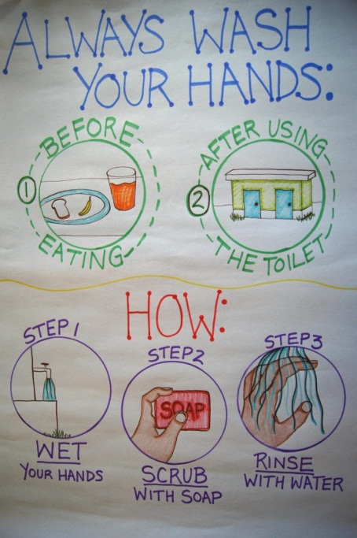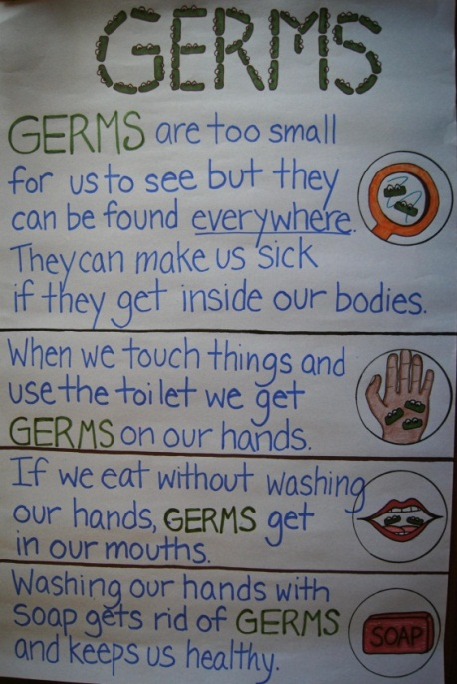Write ?s for next week
     1. ***Lesson 5: Oral Hygiene***

Bring:

* Soap
* Toothbrushes
* Toothpaste

Always Do:

* Write objectives/myth on the board
* Write timeline on the board

Always Bring:

* Bring ? Box
* Bring ? Slips
* Bring name tag cards
* Bring rules

* 1. Pass out soap
  2. Answer last week's questions (5 min)
     1. Review germ and handwashing posters
  3. Introduction and objectives (5 min)
     1. Objectives
     2. Poll
        1. I have a toothbrush.
        2. I have toothpaste.
        3. I have floss.
        4. I brush my teeth every day.
        5. I floss my teeth every day.
        6. I brush my teeth in the morning and at night.
     3. Explain that they should do the following:
        1. Brush teeth in the morning after breakfast and at night after dinner
        2. Floss once a day
        3. Always use toothpaste if you have it
           1. If don't have toothpaste (from poll):

Second best is baking soda and salt (3:1)

Third best is just salt

* 1. Lecture (10 min)
     1. Definitions
        1. Define plaque--sticky, slimy yellow stuff that builds up on our teeth when we don't brush them for a while--made mostly of germs
           1. Show them the dental chart and where plaque builds up
        2. Define cavities--holes in your teeth created by plaque
           1. Sometimes you can see the holes, sometimes you might not see the holes but your tooth will hurt
  2. Activity (10 min)
     1. Watch two videos
        1. Dr. Rabbit (<http://www.youtube.com/watch?v=Fj88PT71P74> )
        2. Kids Cavity (<http://www.youtube.com/watch?v=f7qDYpZJCmY> )
     2. Review tooth brushing poster and steps for brushing teeth
  3. Answer myth and Teach Back (5 min)
  4. Write ?s for next week
     1. ***Lesson 6: Resisting Peer Pressure***

Always Do:

* Write objectives/myth on the board
* Write timeline on the board

Always Bring:

* Bring ? Box
* Bring ? Slips
* Bring name tag cards

* 1. Answer last week's questions (5 min)
  2. Introduction and objectives (5 min)
     1. Objectives
        1. How to effectively make choices
        2. List different situations in which peer pressure occurs
        3. Demonstrate effective skills to resist peer pressure
  3. Lecture (10 min)
     1. Ask for their definition of peer (around the same age, hang out with them a lot) pressure (push you to do things)
        1. Someone close in age to you (ex. Classmates, siblings) that pushes you to change your attitudes, values, or behavior
        2. Can be good or bad
           1. Good-motivated group of friends, want to succeed in school, trying hard to do well on the KCPEs
           2. Bad-friends involved with drugs and alcohol that may be pushing you to use them
     2. Ask class for examples of things they may be pressured to do by peers--both positive and negative (write them horizontally across the board)
        1. Have sex
        2. Drink
        3. Try drugs
     3. Ask for the consequences of each action and write them in a column below each
        1. Consequences of drugs/alcohol:
           1. School problems--bad grades, missing class, dropping out of school
           2. Risky sexual practices--adolescents who drink or use drugs are more likely to have sex, have it younger, and have multiple partners--higher risk of HIV, STIs, unwanted pregnancy
           3. Crime--selling drugs, stealing, violence
           4. Physical consequences—negative effects on mind and body such as memory loss, cancer, infertility, HIV infection from unclean needles
           5. Future problems--younger someone drinks, more likely have problems with alcohol abuse later in life
     4. People find it difficult to say no or make choices that are different from what their friends are doing
        1. One way to avoid this is by choosing friends with similar viewpoints/goals
        2. It's OK to say no and it's important to practice saying no to peer pressure so when it happens--prepared
  4. Activity (10 min)
     1. Three C's for making decisions
        1. The C's:
           1. Recognize the Challenge you are facing
           2. List the Choices you have (3)
           3. Weigh the Consequences of each choice (positive and negative)
        2. Read the following challenge involving peer pressure and discuss choices and consequences with the class:
           1. You have seen how your father's life has been damaged from drinking too much alcohol and have decided never to drink. Your new friend took a bottle of alcohol from their parents and wants to try it after school. They are trying to convince you to come with them and drink it.
        3. Have the class list three choices and the consequences of each
        4. Have the class vote on which choice is the best
        5. Have students get in groups of two and act out a role play of the choice the class made. Assign each student A or B--A's don't want to drink B's stole the alcohol and are pressuring A.
     2. Debrief
        1. Is it hard making good and healthy decisions? Why?
        2. What makes decision making easier?
     3. Answer myth and Teach Back (5 min)
        1. Myth
           1. Saying "no" to drugs or alcohol makes you uncool.
  5. Write ?s for next week

* + 1. ***Lesson 7: Drugs and Alcohol***

Always Do:

* Write objectives/myth on the board
* Write timeline on the board

Always Bring:

* Bring ? Box
* Bring ? Slips
* Bring name tag cards
* Bring rules

* 1. Answer last week's questions (5 min)
  2. Introduction and objectives (5 min)
     1. Objectives
        1. Learn about the effects of alcohol on the body
  3. Lecture (10 min)
     1. People usually drink to feel more relaxed or to relieve stress
     2. General Effects--Drugs and alcohol use can:
        1. Increase risky sexual practices
           1. Having sex at a younger age
           2. Having multiple partners--increases risk of STDs/HIV and unwanted pregnancy
        2. Cause problems at school
           1. Poor grades
           2. Skipping class
           3. Dropping out of school
        3. Lead to juvenile delinquency
           1. Selling drugs
           2. Stealing
           3. Violence
        4. Cause accidents
           1. Car accidents
           2. Drowning
           3. Burns
        5. Cause future problems
           1. Younger someone is when they first drink alcohol, more likely they will become alcoholics (addicted to alcohol) later in life
     3. Contains
        1. Ethanol or ethyl alcohol
        2. Only type of alcohol that is safe to drink, but it's only safe in small amounts
     4. Specific Effects--Alcohol's effect on the body
        1. Affects everyone differently--based on weight, age, etc.
        2. Short-Term (in one night after a few drinks):
           1. If become drunk:

Slurred speech

Poor coordination and slow reaction time--clumsy

Lack of judgment--don't think before acting

Blurry vision

Emotional--crying

Nausea/vomiting

Blackout--someone looks and acts like they are functioning normally but the next day may not remember anything that happened

* + - * 1. Next day--hangover (headache, nausea, diarrhea)
      1. Drunk goggles exercise
         1. Write sentence on the board
         2. Put on glasses and spin around 3 times then write the sentence again
      2. Long-Term (after years of drinking):
         1. Alcoholism (alcohol addiction)--drink even though it causes problems in your life

Drink alone

Become violent when drinking

Can't control drinking--can't stop drinking or drink less

Make excuses to drink

Forget to eat

* + - * 1. Health problems associated with alcoholism

Bleeding of digestive system (stomach/intestines)

Cancer

Memory loss

Depression

Heart damage

High blood pressure

Problems sleeping

* + - * 1. Completely stopping to drink (Abstinence)--best option

Difficult to do

Need strong support of friends and family

* 1. Activity (10 min)
     1. You have seen how your father's life has been damaged from drinking too much alcohol and have decided never to drink. Your new friend took a bottle of alcohol from his parents and wants to try it after school. He is trying to convince you to come with him and drink it.
     2. Write skit about decision made last class
        1. Karima--"tell friend not to drink"
        2. Kaaga--"refuse and give reasons"
     3. What if they continue to pressure you?
        1. Pretend to be an annoying friend and ask over and over to try it, tell them they aren't being cool, etc.
        2. Ask them what they should do--may be better to find new friends
  2. Answer myth and Teach Back (5 min)
  3. Write ?s for next week
     1. ***Lesson 8: Jeopardy Review***

**Correct Answer-10 pts**

**Steal and Correct Answer-15 pts**

**Activity-20 pts**

**Personal Hygiene**

1. When are the two times you should always wash your hands?
   1. Before eating and after using the toilet
2. Why should you use soap and water instead of just water when washing your hands?
   1. It is better at removing germs
3. How often should you shower?
   1. At least once every day
4. When should you brush your teeth?
   1. After every meal or in the morning after breakfast and at night before bed
5. What is one of the best ways to prevent spreading intestinal worms?
   1. Washing hands after using the toilet and before eating
6. List two ways to properly treat water so it is safe to drink.
   1. Use Pur tablets, boil, filter
7. What are germs?
   1. Little things, too small for us to see, that can make us sick if they get inside our bodies
8. Why is it important to thoroughly cook meat before eating it?
   1. To kill any germs or intestinal worm eggs that may be on it

Activity: Write a short song about the importance of washing your hands; the group with the best song wins

**Oral Hygiene**

1. What should you use to brush your teeth if you don’t have toothpaste?
   1. Salt and baking soda or just salt and water
2. What is enamel?
   1. The hard, white shell that protects our teeth
3. What is plaque?
   1. The sticky, slimy yellow stuff that builds up on our teeth when we don’t brush them for a while
4. What are cavities?
   1. Holes in our teeth created by plaque
5. Why should you also brush your tongue when brushing your teeth?
   1. To remove germs and prevent bad breath caused by these germs
6. What is floss used for?
   1. To clean between the teeth where a toothbrush can’t reach

Activity: Hangman—gingivitis (first team to guess the word wins)

**Peer Pressure/Alcohol**

1. What is peer pressure?
   1. When your peers, or someone close to your age, pushes you to do things
2. Is peer pressure always negative or can it be positive too? Give an example.
   1. Yes, it can be positive. Students wanting to do well in school may encourage their friends to study hard
3. List three problems at school that could result from drinking alcohol.
   1. Bad grades, skipping class, dropping out of school
4. If your friend pushes you to try drugs or alcohol, what should you do? What if they keep pushing you?
   1. Refuse and give reasons
5. What are three short-term effects of alcohol on the body?
   1. Blurry vision, slurred speech, slow reaction time, emotional, nausea/vomiting
6. In the example we did in class, why did the students wear glasses and spin around?
   1. Glasses for blurry vision and spinning for poor coordination
7. What is the best way to end an addiction to alcohol (alcoholism)?
   1. Completely stop drinking

Activity: Charades—one representative from each group has to act out “skipping class”; first group to answer gets the points

* 1. ***Girl Talk Lesson Plan***

Preparation

* Pads
* Tablespoon
* 2 clear glasses
* Water
* Question Box and paper slips
* Rag to clean blackboard
* Calendar

1. Preparation—**(write the following on the left side of the board before class)**
   1. Topic: Puberty and Menstruation
   2. Objectives: Learn how our bodies change during puberty
   3. **Draw outline of a girl on the right side of the board**
2. Introduction
   1. Gwen, volunteer at MKMF, seen me around as health club teacher
   2. We are here to talk about things just for girls and some of the things we are talking about might be a little uncomfortable or awkward, so that is why the boys are not here, to make you feel as comfortable as possible
   3. We have a very big group here today so it is important to be quiet and to listen carefully, but I want to encourage you to raise your hand and ask questions if you have any
   4. Go over the topic and objectives
3. Lecture
   1. Puberty is a time when boys’ and girls’ bodies change—when puberty ends, girls’ bodies are able to become pregnant and boys’ bodies are able to get a girl pregnant
      1. Girls: 8-13 yrs old
      2. Lasts about 2-5 years
      3. Everyone is different and girls may start puberty at different times than their friends and that is normal
   2. During this time you will experience both emotional changes, so the way you think or feel may change and physical changes, so your bodies will grow and change
      1. During these changes you may feel awkward or embarrassed, but you should know that everyone goes through puberty and these changes are normal
         1. Your friends will probably be experiencing some of the same things as you so it’s good to talk to each other
         2. Your mothers and other adults have already been through puberty and they know what it felt like, so they are also good to talk to if you have any questions
         3. Everyone develops and changes at different times because everyone is different so you shouldn’t tease other people
      2. One emotional change is that you might start to be attracted to boys and you might start to have sexual feelings
         1. This is very normal and you shouldn’t feel guilty about it, but acting on these feelings is a very big responsibility
         2. When two people really love each other they might have sex
         3. Sex is when a man puts his penis into a woman’s vagina
         4. If a woman has sex, she can become pregnant, get HIV, or get STDs which are diseases that you get by having sex, so it is important to be careful when having sex
         5. Also, just because you love someone, it doesn’t mean you have to have sex, there are many other ways to show someone you love them like hugging and holding hands
         6. It is important not to have sex until you are ready and you feel completely comfortable
         7. You should never let a boy push you or pressure you into having sex
         8. If you have any doubts at all, you should not have sex, it is much better to wait until you are completely ready and comfortable or until you are married
   3. Physical changes for girls
      1. **Illustrate/label the following on the drawing of the girl**
         1. Hips get wider
         2. Hair grows in new places like the armpits and around the vagina
         3. Body odor—new smells under the arms—best to bathe every day and to use deodorant or perfumes
         4. Acne or pimples can develop—washing face with soap and water is important to keep skin clean
         5. Breasts develop and get larger—one may grow faster than the other at first but that is normal and the other one will catch up soon
            1. They may feel sore as they grow
         6. Vaginal liquid—clear or white
         7. First menstrual period—our focus for today
   4. Menstruation
      1. Menstruation is a time when blood comes out of the vagina, it is also called a monthly period because it usually happens once a month **(write “menstruation/monthly period” on the board)**
         1. A girl will know she has started her first period when a little bit of blood comes out of her vagina, she may see spots of blood on her panties, it might look a little brown at first
         2. Sign that a girl can become pregnant if she has sex
         3. It’s also possible for a girl to become pregnant if she has sex right before her first period starts
      2. Girls usually start menstruating between the ages of 12 and 16, but they can start as early as age 8
         1. Each girl will start at a different time, so don’t worry if your friend has started menstruating and you haven’t
         2. One of my best friends started menstruating for the first time in class 4, but my other friends didn’t start until class 7 or 8 and that is completely normal
      3. You won’t have menstruation your whole life, periods stop between the age of 45-51, when menstruation stops, a woman can no longer become pregnant
      4. Signs it will start soon:
         1. About 2 years after girls’ breasts start to develop they usually get their first menstrual period
         2. Another sign is a thick white liquid coming from the vagina, usually menstruation happens about 6 months after this
   5. Pads
      1. Menstruation usually lasts for 3-7 days
         1. **Draw a timeline on the board:**
            1. Days 1 2 3 4 5 6 7
      2. Using a pad:
         1. Pads work like sponges to soak up the blood
         2. To use a pad, remove the plastic and place the sticky side on panties **(unwrap pad and demonstrate—draw panties on board) (pass medium pad around so they can feel the sticky back)**
         3. The amount of blood will change each day so there are different sizes and types of pads
         4. Usually when your period is starting the blood will be brown **(write “brown” under “Day 1”)** and there won’t be a lot of blood so you can use a thin pad called a “panty liner” **(stick it to the board under “Day 1”) (explain that liners can also be used around the time your period is supposed to come in case you get it a few days early)**
         5. Usually there is the most blood on the second day so some pads are bigger and thicker to soak up more **blood (stick the overnight pad to the board under “Day 2”)**, during this time the blood is redder **(write “red” under “Day 2”)**
         6. When the period is ending there will be less blood again and it will be browner **(write “brown” under “Days 6 & 7” and point to the liner again)**
         7. About 2-4 tablespoonsof blood comes out of the vagina over the 3-7 days **(pour 4T of water into the clear glass)** this won’t all come out at the same time, this is the total amount of blood that will come out of the vagina during one period
         8. Blood does not pour out of the vagina, it drips out slowly **(pour water, then drip it onto the overnight pad)**
         9. Should take off a pad and put on a new one every 3-4 hours, or sooner if there is a lot of blood
         10. Change it 3-6 times a day even if there isn’t a lot of blood
             1. This will prevent germs from building up and prevent bad smells
         11. Pads can only be used once, they can’t be washed
         12. When you are finished with a pad you should throw it down a pit latrine but never flush a pad down a toilet because it will get stuck and the water will flow over the top of the toilet
         13. If you do not have a pit latrine, you should wrap it nicely and put it in a paper bag and put it in a dustbin
      3. Pads can be expensive to buy, so if you do not have pads, you can cut pieces of clean cloth to fit into your panties
         1. You should sew 4 or 5 layers together so the blood does not soak through
         2. You can see it is thick and loose, so to stay comfortable you should use it with tight, but comfortable panties
         3. It is important to make sure the cloth is clean and to wash it really well with soap and water after it is used
         4. They should be hung up in a private but sunny place to dry
         5. Once they are clean and dry, they can be used again
         6. You should never share cloth pads with other people, you should have your own just for you
      4. Important to plan ahead using a calendar, usually menstruation happens every 28 days, or one time a month, so it is possible to figure out when your next period will start so you can use a pad and prevent stains on your clothes
         1. If blood gets on the back of your dress, you can tie your sweater around your waist
         2. When you get home you should wash your clothes in cold water with a little salt
         3. Using hot water will make the stain permanent and you won’t be able to wash it off, so don’t use hot water to wash off blood
   6. Cycle
      1. **Demonstrate on the calendar**
      2. Happens once a month **(circle a month)**
      3. Lasts 3-7 days **(outline a week)**
      4. 28 days from the first day of one period until the first day of the next period—meaning you usually get it once a month **(show them an example on the calendar then pick a random day and have someone come up and calculate when the next one will be)**
      5. For the first few years it may be irregular, meaning it might come more than once a month, or it may skip a month
      6. If you think your period is comings soon, you can use panty liners
      7. It is important to be prepared and have pads with you around the time you’re supposed to get your period
      8. I always carry one with me **(show them the bag)** you can put it in something like this, or carry one in your backpack, at the end of the lesson you will each get a pad to keep with you in case you start your period for the first time while at school
      9. If you get your period and you aren’t prepared, ask a friend or a teacher you trust to borrow a pad from them
   7. Side Effects
      1. Having a period and having blood come out of your vagina doesn’t hurt, but cramps or stomach pains can
      2. Not everyone will get cramps and some people’s cramps hurt more than others
      3. Cramps or stomach pains—can be treated with a hot water bottle, hot bath, or exercise, but if the cramps are severe you can take pain killer medicine like panadol
      4. If your cramps are very severe and there is a lot of blood, you should talk to a doctor; if you have menstruation for longer than a week, you should also talk to a doctor because something might be wrong
      5. Other things you might feel or that might happen while you are menstruating are back pain, headaches, nausea (upset stomach), vomiting, constipation (not being able to poop), but these things will not happen to everyone
      6. All of these things including cramps usually last only the first two or three days
   8. What does it mean?
      1. Can continue doing things as you normally do
      2. Can still play outside and play sports while you are on your period
      3. Tampons
         1. Can swim while menstruating, but can’t use a pad while in the water because it will soak up the water like it soaks up blood and then it will feel like you’re wearing a diaper
         2. It’s best to use a tampon if you are swimming
         3. A tampon is put inside of the vagina
            1. First you take off the plastic on the outside and then you push it up into your vagina with a string hanging outside of the vagina to pull it out **(show them an example of a tampon)**
            2. The string is very strong and should not break
            3. It is not possible to get a tampon lost inside of your body, you will always be able to remove it
         4. A tampon works by soaking up the blood before it leaves the vagina and a pad works by soaking up the blood after it leaves the vagina **(draw on the diagram)**
         5. You may feel more comfortable using a tampon after having your period a few times because they can be uncomfortable to use at first—look for directions inside of the box so you know how to use it correctly
         6. If you are nervous, it may be hard to get the tampon in, so you should relax and wait a minute before trying again
         7. Using a tampon or a pad is a personal choice and after trying both you might like one of them better
         8. It is especially important to change tampons regularly, like a pad they should be changed every 3-4 hours, 8 hours is the absolute longest a tampon should stay in
         9. If a tampon stays in your body for too long, so more than 8 hours, you can get an infection which can make you very sick, so don’t forget to take out your tampon and change it every 3-4 hours, that is very important
         10. If you have a tampon in and you start to feel dizzy or sick, you should immediately take it out and tell an adult right away
      4. Every girl will get their period during their life and it is not something to be afraid of or be embarrassed about
      5. Without menstruation, women would not be able to have children
      6. You might feel uncomfortable the first time you get your period, but don’t worry, it is completely normal and natural
      7. It is important to talk to your mother, sister, friends, or even an adult that you feel comfortable with and trust before you start menstruation and again after you start menstruation
   9. Myths
      1. Explain “myth” as something that is a belief or story which is not true and “fact” as something which is true
         1. Ex. of Myth: Eating carrots will turn your skin orange
         2. Ex. of Fact: Jomo Kenyatta was the first president of Kenya
         3. Call up two groups of three to answer the following questions as either myths or facts—10 points for each correct answer
      2. The blood coming from a woman during menstruation means that she is sick (MYTH)
         1. Menstruation is normal and happens to every woman, it does not mean that she is sick
      3. Cold drinks cause menstrual cramps (MYTH)
      4. Women should not eat spicy or sour foods during menstruation (MYTH)
      5. If a woman does not have her period one month, this could mean she is pregnant (FACT)
         1. But it doesn’t always mean a girl is pregnant, remember that your period probably won’t be regular when you first get it, and you may miss a month or two, meaning you might not have your period every month at first
         2. Also, if you have never had sex, you will not be pregnant
      6. It is safe for a woman to wash her hair or take a bath during her period (FACT)
         1. It is important for girls to bathe every day, especially when on her period
      7. Having menstrual blood means a woman is dirty (MYTH)
         1. The blood that comes out is not dirty it is normal and natural but it is important to stay clean and bathe every day
      8. Boys have menstruation too (MYTH)
         1. Boys don’t have vaginas and cannot get pregnant, so they do not have menstruation
      9. If you have menstruation you should skip school (MYTH)
         1. When you have your period you can still go to school just like how you can still play outside with your friends and play sports
         2. Having your period shouldn’t keep you from doing things you normally do
   10. Question Box
       1. Explain the purpose of the question box and allow each girl to write down a question
       2. Spend the remainder of class answering questions
   11. Teach Back
       1. Ask three girls to stand up and each say one thing that they learned
   12. Pass out a pad to each girl
       1. Do not open the pad until you are ready to use it
       2. Make sure to keep it in a clean, dry place
       3. It might be good to put it in a plastic bag and carry it in your backpack
   13. ***HIV Talk Lesson Plan***

Preparation

* Question Box
* Question Slips
* Condoms
* Paper slips for game
* Big sheets of paper
* Markers

1. Preparation—**(write the following on the left side of the board before class)**
   1. Topic: HIV/AIDS
   2. Objectives:
   3. “Word Bank” in a box
2. Introduction
   1. Gwen, volunteer at MKMF, volunteer at SOS Kindergarten
   2. Do you know what today is?
   3. Today is World AIDS Day, and it has been celebrated every December 1st since 1988
   4. This means that all around the world people are working together to fight against HIV, spread awareness, show support for people with HIV, and remember those who have died
   5. About 33.3 million people in the world have HIV currently and over 25 million people have died as a result of AIDS
   6. In Kenya there are about 1,500,000 people living with HIV/AIDS which is 6.3% of the population
      1. Of those 1,500,000 people, 180,000 of them are children and 1,200,000 children have become orphans as a result of AIDS
   7. **Give each person a slip of paper and instruct them to write down something that they have heard about HIV or AIDS from friends or at school, tell them that they don’t have to agree with what they heard**
      1. Read each statement out loud and write their answers in two columns without commenting
      2. True goes on the left and False goes on the right, but don’t label the columns
      3. Ask the class what each column has in common, tell them the answer if they don’t get it
      4. Tell them I will explain the reasons why during the class
3. HIV is a virus, or a germ, that leads to AIDS
   1. HIV
      1. Tests can be taken to find out if someone has HIV or not, a positive test means that someone has HIV **(write “HIV+=has HIV in the Word Bank)** a negative test means that someone does not have HIV **(write “HIV-=does not have HIV” in the Word Bank)**
      2. HIV attacks the immune system which protects our bodies from germs and diseases, think of your immune system as an army inside of your body that finds germs and fights them off **(write “immune system=body’s army or defense system against germs” in Word Bank)**
      3. Since people with HIV can have weaker immune systems, their bodies have a harder time fighting off these germs, so they get sick more easily
      4. The immune system gets weaker and weaker until it can’t fight off other diseases and eventually the HIV+ person can die
      5. No cure or vaccine (shot) to prevent getting it, but if you know how HIV is spread, you can do things to prevent getting it which I will explain later
      6. This means that someone who has HIV has it for the rest of their life, they won’t outgrow it and it won’t go away like a cold, they will always have it
      7. As soon as someone gets HIV they can pass HIV to other people
   2. AIDS
      1. A later stage, and the most serious stage, of HIV **(write “AIDS=later, more serious stage of HIV” in Word Bank)**
      2. If someone has AIDS, they still have HIV and are considered HIV+
      3. Someone might have AIDS after they have had HIV for many years, sometimes for up to 10 or even 20 years if they take medicine to treat the symptoms of their HIV, by treating these symptoms, AIDS can start later in someone’s life, keeping them healthy longer
      4. If someone with HIV becomes sick with many other illnesses or diseases that can’t be treated with medicine, that person has AIDS
      5. Sometimes people with HIV don’t have any symptoms and if they don’t get tested, they can have AIDS before they even realize that they had HIV
4. HIV Transmission—how is HIV passed between people?
   1. Anyone can get HIV, it doesn’t matter if they’re young or old, a boy or a girl, rich or poor, etc.
   2. HIV is passed through infected blood, semen, vaginal fluids, and breastmilk which are all bodily fluids, or liquids that come from the body
   3. There are three main ways that HIV is passed from one person to another **(write each one on the board as I go along)**:
      1. **SEX—**The number one way that HIV is passed between people is by having unprotected sex, or sex without a condom, with someone who is HIV+
         1. Sex occurs when a man puts his penis inside of the vagina, anus, or mouth of another person
         2. During sex both men and women can get HIV, or get STIs (sexually transmitted infections) which are diseases or infections that you get by having sex **(write “STIs=sexually transmitted infections (diseases passed during sex)” in Word Bank)**
         3. Also during sex, a woman can become pregnant and if she has HIV or STIs, her baby will be at a risk for getting HIV and STIs, and so it is important to be careful when having sex
         4. Two people who love each other very much might have sex
         5. But, just because you love someone, it doesn’t mean you have to have sex, there are many other ways to show someone you love them like hugging and holding hands
         6. It is important not to have sex until you are ready and you feel completely comfortable
         7. You should never let someone push you or pressure you into having sex because it is a very big and personal decision
         8. If you have any doubts at all, you should not have sex, it is much better to wait until you are completely ready and comfortable or until you are married
      2. **BLOOD TO BLOOD—**HIV can be passed from an HIV+ person’s blood to another person’s blood through an opening in the body, like a cut, or by sharing needles with someone who has HIV
      3. **MOTHER TO CHILD—**From a mother to her child while an HIV+ woman is pregnant, giving birth, or breastfeeding
   4. HIV **cannot** be passed **(draw each one and then cross it out as I go along)**:
      1. By kissing, hugging, touching, or shaking hands with someone who is HIV+ or by living with them
      2. By mosquito bites or other bug bites
      3. By someone with HIV sneezing or coughing near you or on you
      4. Through tears, spit, or sweat
      5. By sharing cups, plates, forks, knives or spoons
      6. Using public bathrooms
      7. In swimming pools
      8. By pets
5. Prevention
   1. **Ask the class how HIV could be prevented for each of the three methods of transmission, point to sex, then blood to blood, and then mother to child**
   2. **Write “ABC” on the board vertically and label each letter as I explain it**
      1. The best way to avoid getting HIV by having sex is to not have sex
         1. Abstinence **(write it on the board)** means not having sex and it is the only way to avoid HIV 100%
         2. Having sex with a condom is not 100% effective because condoms can sometimes break or come off during sex if they are used improperly
         3. However, if they are used correctly, condoms provide 10,000 times more protection against HIV infection than not using condoms
      2. That is why if someone has sex, it is important for them to be protected and use Condoms **(write it on the board)**
         1. In addition to preventing HIV infection, condoms can prevent unwanted pregnancies and STIs
            1. If someone has an STI it is much easier for them to get HIV
            2. Just like HIV, sometimes people with STIs will not have any signs or symptoms so a person will not know if they have an STI unless they are tested for them
            3. Some STIs can be cured, which means that if someone takes medicine they will go away, but some can’t be cured, so once someone has one, they will have it for the rest of their life
         2. Always use a condom even if you don’t think the person you are having sex with has HIV or an STI
            1. If the person you are going to have sex with refuses to use a condom, you should tell them that you will not have sex with them without one
         3. This is what a condom looks like**—hold up example**
   3. Don’t share needles
      1. When you go to the doctor to get a shot, make sure the doctor is using a new, clean needle
      2. People who use injectable hard drugs sometimes share needles and after one person uses it, some of their blood can be left in the needle. If someone else then uses that same needle, the other person’s blood will get into their body. If the first person has HIV then the second person can get it by using the same needle.
      3. Drugs are harmful to our bodies and it is best to avoid them altogether.
      4. People who use drugs or drink alcohol have a harder time making good choices and they are more likely to have sex or to have sex without a condom which can lead to HIV, STIs, and unwanted pregnancies
   4. Mother to child prevention
      1. By receiving treatment, which we will talk more about later, the chance of a mother passing HIV to her child is much lower
      2. Also, a mother can prevent passing HIV to her child by feeding the baby formula milk instead of breastfeeding, but this is a personal decision to be made by the mother and it is best for her to talk to a doctor for advice when she is deciding
6. HIV Activity
   1. **Make paper slips**
      1. Two with a “y” in the corner (HIV)
      2. Three with a “c” in the corner (condom)
      3. Three with “Don’t follow any of my directions until I tell everyone to return to their seats”
      4. The remainder with “follow all of my directions”
   2. This is just a game, it is not real, I am just using it as an example
   3. Give each person a paper, tell them to keep what it says secret and to follow the instructions on their paper
   4. Stand up, walk around the room, and shake hands with three people and ask each person to sign your paper
   5. Sit back down
   6. If you had a “y” on your paper, please stand up
   7. If you shook hands with either of them, please stand up
   8. Ask people who shook hands with the standing people to stand up, tell them to remain standing until I tell them to sit, keep going until only the three people told not to follow instructions are still sitting
   9. I want you to pretend that the person with the “y” on their paper had HIV and that instead of shaking hands, they had unprotected sex, without a condom
   10. All of the people who shook hands with person “y” now also have HIV and so do the people who shook hands with them
   11. Ask people who are sitting why and explain that they had chosen not to have sex so they were protected from HIV
   12. If you have a “c” on your paper you can sit back down. People with “c”’s used condoms so they did not get HIV
   13. Remember, this was just a game and remember that you cannot get HIV by shaking someone’s hand
   14. Discussion:
       1. How did you feel if you had a “y” on your paper? How did you feel knowing that the people who shook your hand got HIV?
       2. How did you feel at the beginning of the game if you were told not to follow the instructions? How did you feel at the end when you found out that you hadn’t had sex?
          1. How did everyone who followed directions feel when they saw them sitting?
       3. Did anyone have a paper that said not to follow instructions, but did anyway? Why? Did they feel pressured to participate?
       4. How did you feel if you had a “c” on your paper?
       5. How did you feel if you shook hands with someone with a “y” and then found out that they had HIV?
       6. Was there any way of knowing when the game started what the letters on peoples’ papers meant? Is there any way of knowing if someone has HIV just by looking at them?
   15. In this kind of situation, it would have been best to either not have sex or to use a condom during sex
7. Testing
   1. It is impossible to tell if someone has HIV just by looking at them because many people with HIV can look and feel healthy
   2. Sometimes it takes many years after someone gets HIV for symptoms or signs to even show up
   3. The only way to know if someone has HIV is if they get tested for HIV
   4. After you or your partner are tested, it is important for both of you to Be Faithful **(write it on the board)** becauseas soon as either of you have sex with someone new (especially without a condom), both of you risk being infected with HIV and need to get tested again because the unfaithful partner could have spread HIV or STIs to their partner
   5. In Kenya there is something called VCT (Voluntary Counseling and Testing)
      1. It is a process where people can learn whether or not they are infected with HIV
      2. People who are tested for HIV also receive counseling to help them learn how to take care of themselves if they are positive or prevent getting HIV if they are negative
      3. The test is reliable, accurate, safe, painless, and FREE! So there is no reason not to get tested
      4. Benefits:
         1. You may feel better knowing if you do or don’t have HIV, even if the result is positive, because you will no longer have to worry, you will know for sure
            1. Remember that even if you are HIV-, you can still get HIV, it is important for everyone to take precautions and be careful even if they are HIV+, HIV-, or if they don’t know
         2. It helps HIV+ people protect others from HIV infection
         3. If the test is taken soon after infection and the result is positive, treatment can begin early
8. Treatment
   1. A cure means that the germ that causes a disease has been killed completely in someone’s body **(write “cure=germs have been killed and disease is gone” in Word Bank)**
   2. There is no cure for HIV, but there are ways to treat the symptoms of it and make someone feel better with medicine **(write “treatment=medicine to make symptoms better, but disease is still there” in Word Bank)**
   3. The combination of medicines used to treat HIV is called ART (anti-retroviral therapy)
      1. This medicine slows down HIV from spreading in the body and helps to strengthen the immune system
      2. If we didn’t have immune systems to fight off germs, we would be sick all of the time
      3. The medicine works by reducing the amount of HIV in someone’s blood
      4. Someone with HIV who is receiving treatment is much less likely to pass HIV to someone else than someone who is not being treated, but they still need to be careful and remember that all of the ways that HIV can be passed from person to person
   4. People with HIV can also stay healthy longer by eating healthy foods, practicing good personal hygiene, staying active, and going to the doctor as soon as there are signs of an illness or infection
9. BREAK
10. Stigma
    1. Stigma of HIV is the discrimination of someone who has HIV because of misunderstanding or misbeliefs about HIV and AIDS that people may have in a community
    2. What are some examples of HIV stigma that you have seen in your community, meaning in school, in town, or at home?
    3. How did it make you feel to see or hear those things? How do you think the person being discriminated against felt?
11. Myths
    1. Explain “myth” as something that is a belief or story which is not true and “fact” as something which is true
       1. Ex. of Myth: Eating carrots will turn your skin orange
       2. Ex. of Fact: Jomo Kenyatta was the first president of Kenya
       3. Call up two groups of three to answer the following questions as either myths or facts—10 points for each correct answer
    2. Birth control pills or birth control shots prevent someone from getting HIV (MYTH)
       1. No, birth control only prevents a girl from getting pregnant, condoms are the only forms of birth control that also prevent HIV infection
    3. It is impossible to get HIV if you only have sex one time (MYTH)
       1. It is possible to get HIV every time you have sex if the person you are having sex with has HIV, but using condoms can greatly decrease the chance that you will get HIV
    4. As soon as someone gets HIV, they can feel a change in their body (MYTH)
       1. Many people will continue to look and feel healthy after they get HIV
    5. If someone is tested for HIV and is HIV+, they should tell their sexual partner (FACT)
       1. It is important to tell your sexual partner if you have HIV so that they can also get tested and to help prevent infecting your partner if they don’t have HIV
    6. People who have HIV got it because they committed a sin (MYTH)
       1. People who have HIV did not get it because they “deserve” it and it wasn’t because they committed a sin
    7. The number of new HIV infections around the world each year has decreased (FACT)
       1. Since 1997 the number of new HIV infections has decreased by 21%
    8. If you get HIV you’ll die soon (MYTH)
       1. There isn’t a cure, but treatment can allow people to live long healthy lives, but it is important to get tested and treated early because the longer someone has HIV, the more it can damage their body and the greater the chance is that someone will get AIDS and die
    9. If someone is tested for HIV and their test is negative, meaning they don’t have it, they can still get it if they have unprotected sex with an HIV+ person (FACT)
       1. Having a negative test result just means that that person doesn’t have HIV currently, but they can still get it
    10. There is still a high risk of getting HIV while using condoms because the pores, or holes, in the condom’s material are big enough for HIV to fit through (MYTH)
        1. HIV can’t pass through condoms, the only reason that condoms aren’t 100% effective at preventing HIV infection is because condoms can sometimes break or come off during sex if they aren’t used properly
    11. Having sex with a virgin, meaning someone who has never had sex before, cures an HIV+ man of HIV (MYTH)
        1. There is no cure for HIV and having sex with a virgin could result in the virgin getting HIV
    12. Condoms are dangerous to use because they can be coated with HIV (MYTH)
        1. Condoms are tested scientifically by the companies that make them and there are strict rules that they must follow. If this were true, many more people would have HIV than currently do.
    13. BONUS POINTS:
        1. What does HIV stand for?
           1. **HIV—Human Immunodeficiency Virus**
        2. What does AIDS stand for?
           1. **AIDS—Acquired** (Get from other people, doesn’t develop on its own)
           2. **Immunodeficiency** (Weakened immune system unable to fight infections)
           3. **Syndrome** (Specific group of symptoms or diseases which doctors define as AIDS)
12. Question Box
    1. Explain the purpose of the question box and allow each person to write down a question
    2. Spend the remainder of class answering questions
13. Teach Back
    1. Ask three people to stand up and each say one thing that they learned

If someone asks:

1. Origin of HIV
   1. No one knows for sure where HIV first came from, but most people believe that HIV was passed to humans through interaction with monkeys
   2. Some monkeys have a virus that is similar to HIV
   3. Hunters killing and eating monkey meat could have gotten blood from the monkeys into their bodies through cuts in their hands
   4. ***Meru District Hospital Malnutrition Interview Questionnaire***
2. **Mother**
   1. Age
   2. Years of education
      1. *If attended school,* Did you learn about malnutrition in school?
   3. Hometown
   4. Occupation
   5. Marital Status
      1. *If married,* What is your husband’s occupation?
3. **Family**
   1. Where did you give birth? *(to the malnourished child)* 
      1. *If at a hospital,* Did you receive nutrition counseling?
   2. Children
      1. Number
      2. Ages
      3. *If other kids aren’t at the hospital,* Is there someone taking care of your children at home?
      4. Have any of your other children been treated for malnutrition?
      5. Have you ever personally known someone with a malnourished child?
      6. When/why did you know to take your child to the hospital?
         1. *If taken for other symptoms,* What symptoms?
      7. Did you first go to a different hospital? *(Were they referred)*
   3. Home Diet
      1. What does a typical meal for your child consist of?
      2. Do you eat the same food as your child?
      3. Where do you get food from?
      4. *If child is old enough to attend school,* Is there a feeding program at your child’s school?
         1. Do you use it?
         2. How much does it cost?
   4. ***School Feeding Program Assessment Questionnaire***
   5. School Name
   6. School Enrollment
      1. Past 5 Years
      2. Current Year Boys/Girls
      3. Are nursery or special classes included?
      4. Number of teachers
   7. Kids affected by drought?
      1. What is the general attendance pattern?
         1. Are kids missing school because of hunger?
      2. Are there nearby schools with feeding programs?
      3. Have any kids transferred to these schools?
      4. Do kids bring a lunch or go home?
         1. If they bring lunch, do many kids have food to bring?
         2. If they go home, do kids typically return after lunch?
   8. Feeding program in the past?
      1. Is another organization/the gov. currently looking to help them with food?
      2. Does the school currently have a plan to start a feeding program?
   9. Cooking
      1. Have a kitchen?
      2. Have a cook?
         1. How many cooks will they need?
         2. If porridge is provided, how quickly can they get a cook?
         3. Who pays for the cook?
         4. How much?
      3. Is there access to water for cooking the porridge?
      4. Must the kids provide their own cups?
      5. Will it be served during break or lunch?
         1. What time is break?
         2. What time is lunch?
   10. Estimates for amount of porridge needed per day
       1. Try to base it off of past feeding programs (if there was one)
       2. Encourage to use a standard measurement so all kids get equal amount of porridge
   11. Toilet Assessment
       1. Take photos
       2. Do they need a new block or a renovation?
       3. Soil quality (rocky, etc.)?

Drop-off

1. Ask head teacher to keep track of enrollment rates and attendance
   1. ***Image of Final Art Project at the Meru School for Mentally Challenged Children***

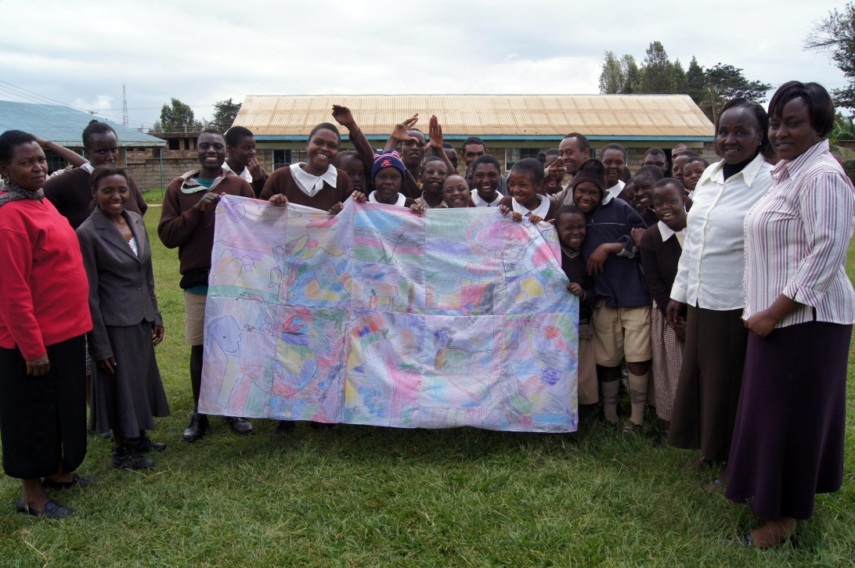

* 1. ***Kanana Mubichi Memorial Library Promotional Poster***



* 1. ***Makena Textiles***
     1. ***Logo***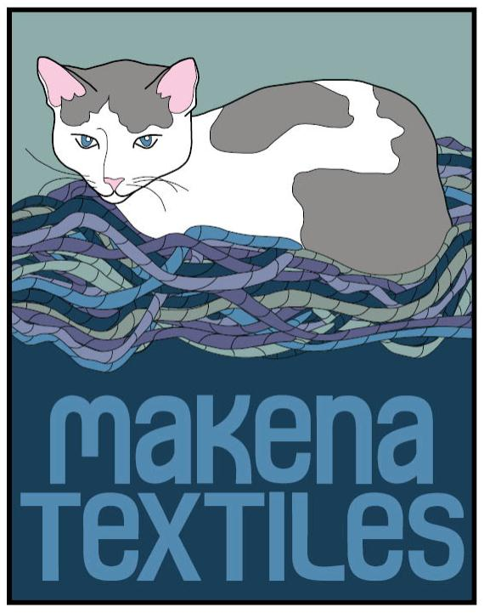
     2. 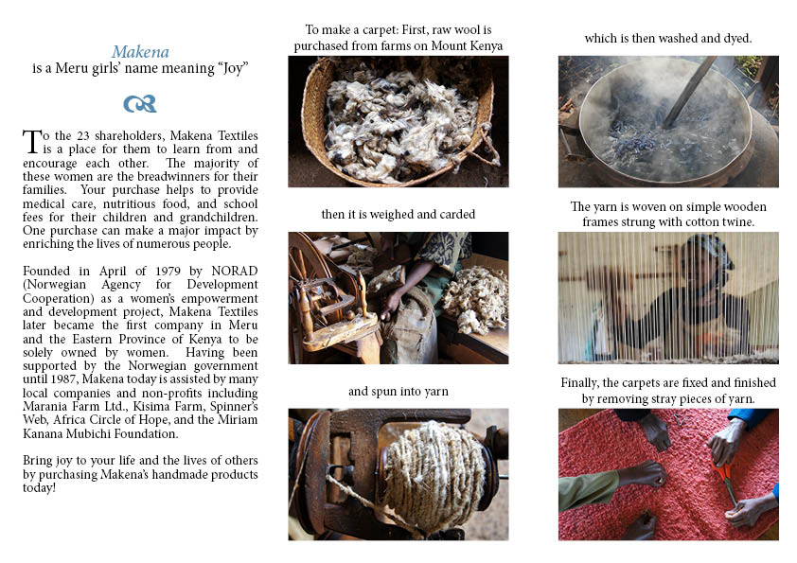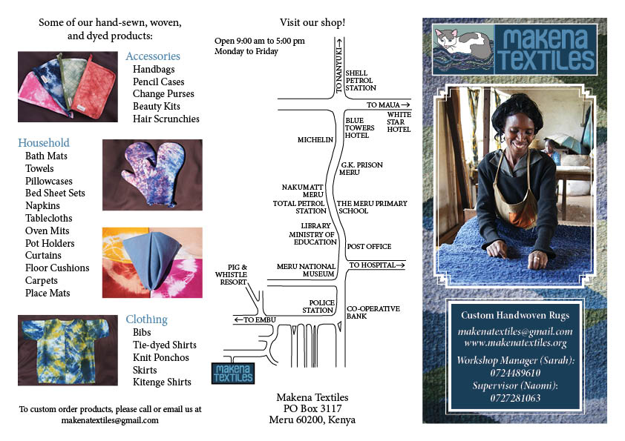***Brochure***
     3. ***Business Cards***

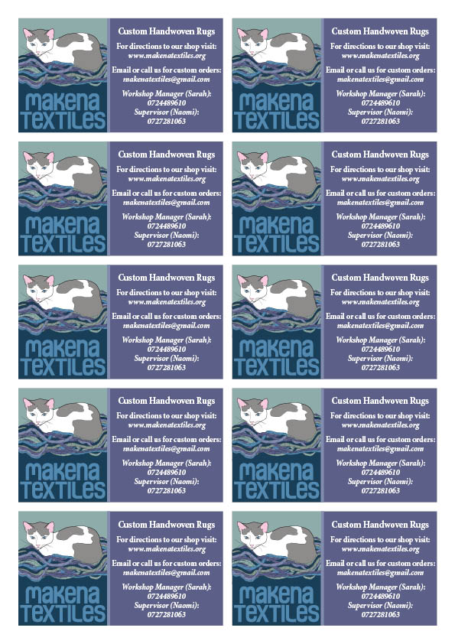

* 1. ***Beads for Peace***
     1. ***Logo***
     2. ***Jewelry Tags***

